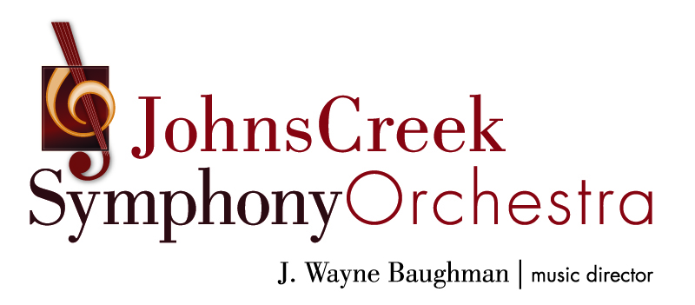

Rate card for 2020-2021 SEASON Advertising
2020-2021 season:
(Dates, artists, and concerts subject to change)

Classical concert TBA
November 7, 2020

A Kids’ Christmas
December 19, 2020

Christmas Gala Holiday Pops
December 19, 2020

Classical Concert TBA
March 27, 2021

Concerts at Johns Creek United Methodist Church, 11180 Medlock Bridge Road, unless otherwise indicated.

Estimated circulation: 2,500.
Ad size (w x h) | Full Rate | Chamber Member Price
5” x 8” no bleed  6” x 9” bleed  Full color  REAR COVER | $1,599 | $1,439
5” x 8” no bleed  6” x 9” bleed  Full color  INSIDE FRONT COVER | $1,299 | $1,169
5” x 8” no bleed  6” x 9” bleed  Full color  INSIDE BACK COVER | $999 | $899
5” x 8”  Full page | $749 | $674
5” x 3 7/8”  Half page | $399 | $359
2 7/16” x 3 7/8” OR  5” x 1 ¾”  Quarter page | $239 | $215
2 7/16” x 1 3/4”  Eighth page | $149 | $134

Deadline:
Artwork due no later than September 18, 2020
Payment for ad due 30 days after reservation, but no later than September 18, 2020. Ad space cannot be held without payment.

All rates are net. Advertising artwork must be supplied to the JCSO in pdf form.

For questions or to place an ad, contact:
Ashley Rausch, JCSO Marketing Manager
asalimpr@gmail.com; (678) 313-1096

