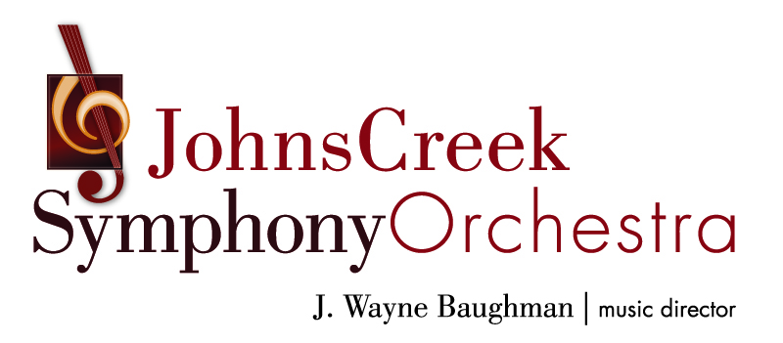

Rate card for 2019-2020 SEASON Advertising
The Program Book will be distributed at the following concerts in the 2019-2020 season:
(dates and concerts subject to change)

Music in the Park
City of Johns Creek Summer Concert Series
October 5, 2019
Newtown Park
3150 Old Alabama Road
FREE ADMISSION

Pops concert TBA
November 16, 2019

Christmas Gala Holiday Pops
December 21, 2019

Classical Concert TBA
March 28, 2020

Concerts at Johns Creek United Methodist Church, 11180 Medlock Bridge Road, unless otherwise indicated.
Ad size (w x h) | Full Rate | Chamber Member Price
5” x 8” no bleed  6” x 9” bleed  Full color  REAR COVER | $1,050  SOLD! | $945  SOLD!
5” x 8” no bleed  6” x 9” bleed  Full color  INSIDE FRONT COVER | $899 | $801
5” x 8” no bleed  6” x 9” bleed  Full color  INSIDE BACK COVER | $764  SOLD! | $687  SOLD!
5” x 8”  Full page | $589 | $530
5” x 3 7/8”  Half page | $381 | $343
2 7/16” x 3 7/8” OR  5” x 1 ¾”  Quarter page | $247 | $222
2 7/16” x 1 3/4”  Eighth page | $161 | $145

Deadline:
Artwork due no later than August 31, 2019
Payment for ad due 30 days after reservation, but no later than August 31, 2019. Ad space cannot be held without payment.

Estimated circulation: 4,320 for the full season.
All rates are net. Advertising artwork must be supplied to the Johns Creek Symphony Orchestra in pdf form.

For questions or to place an ad, contact:
Linda Brill, Johns Creek Symphony Orchestra Executive Director
linda.e.brill@gmail.com; (614) 975-3495

2019-2020 PROGRAM ADVERTISING CONTRACT

Name of Contact:

Business:

Street Address:

City: State: Zip:

Email: Phone:

Size of Ad Purchased:

I will be paying:
By cash, enclosed
By check, enclosed (Payable to Johns Creek Symphony Orchestra)
By credit card (Discover, VISA, MC, AmEx. Please add $5 convenience charge below.
Card Number:
Expiration: Security Code:

Price of Ad: $

Credit card $5 surcharge (if applicable): $

Total amount due: $

Advertiser’s Signature Printed Name

Advertiser’s Title Date

Advertiser agrees to provide the advertising copy and payment in full directly to the Johns Creek Symphony Orchestra. Payment is due within 30 days of reserving ad, but no later than August 31, 2019. Ad space cannot be held without payment. Design and/or production assistance is available at an additional charge. Any agreements regarding placement of the artwork within the program must appear in writing on the contract. JCSO reserves the right to refuse publication of any advertisement that does not meet or exceed its artist or editorial standards.

Mail or email completed contract to:
Johns Creek Symphony Orchestra Program Advertising
11877 Douglas Road, Suite 102-294, Johns Creek, GA 30005; linda.e.brill@gmail.com

